**Experiment No. 1**

**Aim:** Installing Linux: Quick Installation, Detailed installation procedure, Special Installation topics.

**Installation Steps:**

**Step 1:**

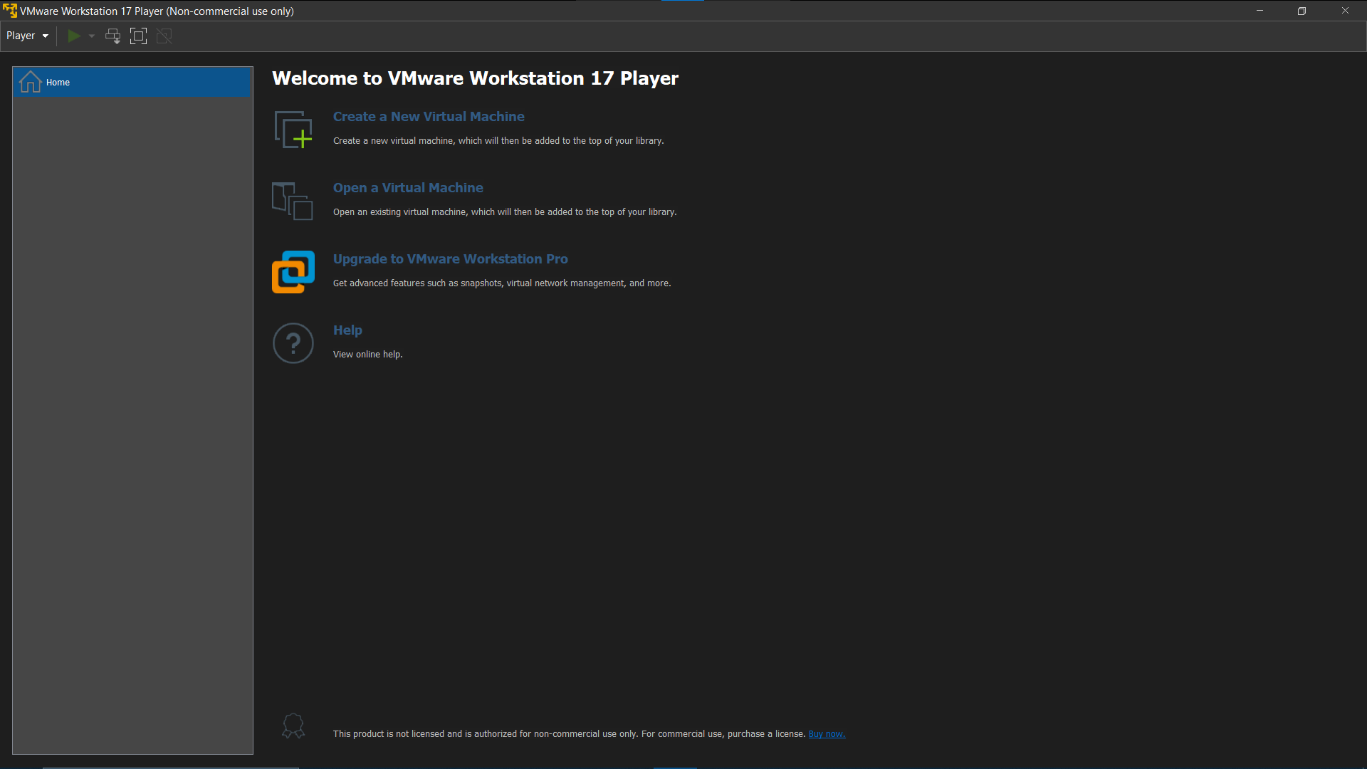

**Step 2:**

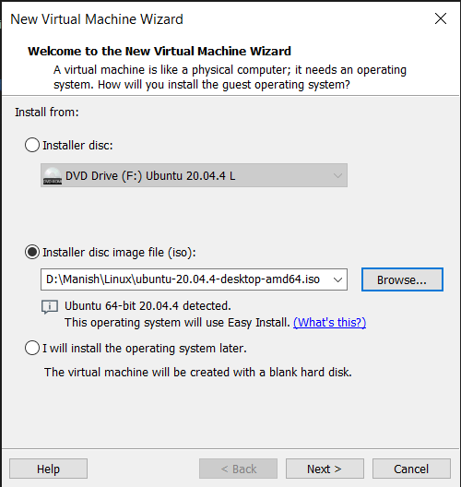

**Step 3:**

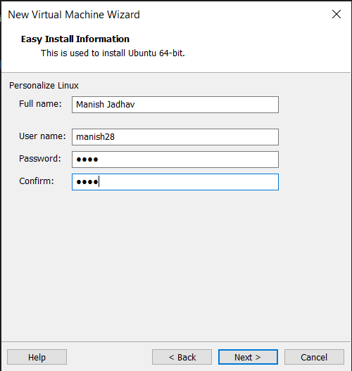

**Step 4:**

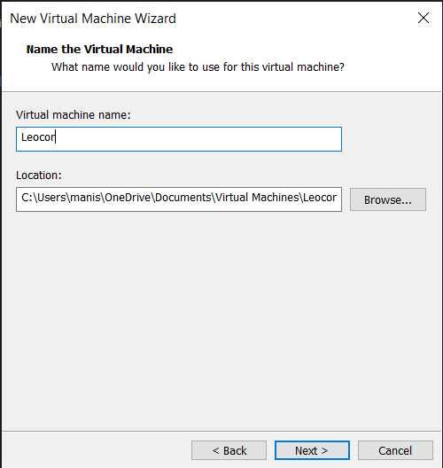

**Step 5:**

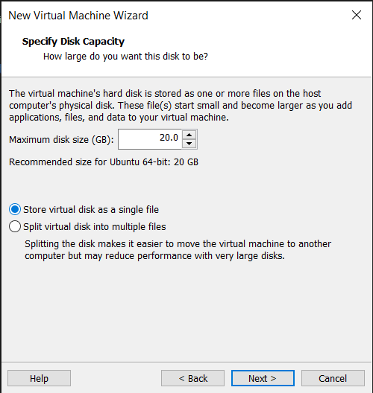

**Step 6:**

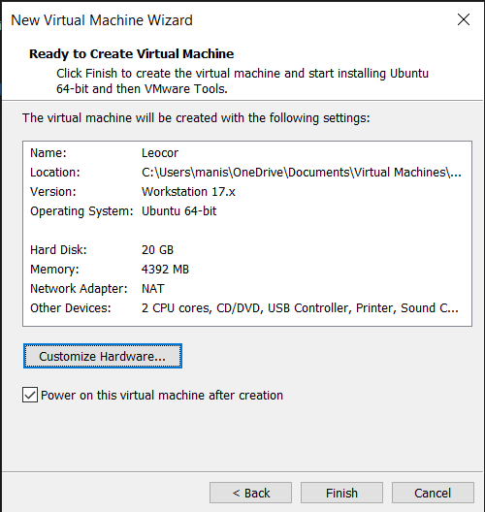

**Step 7:**

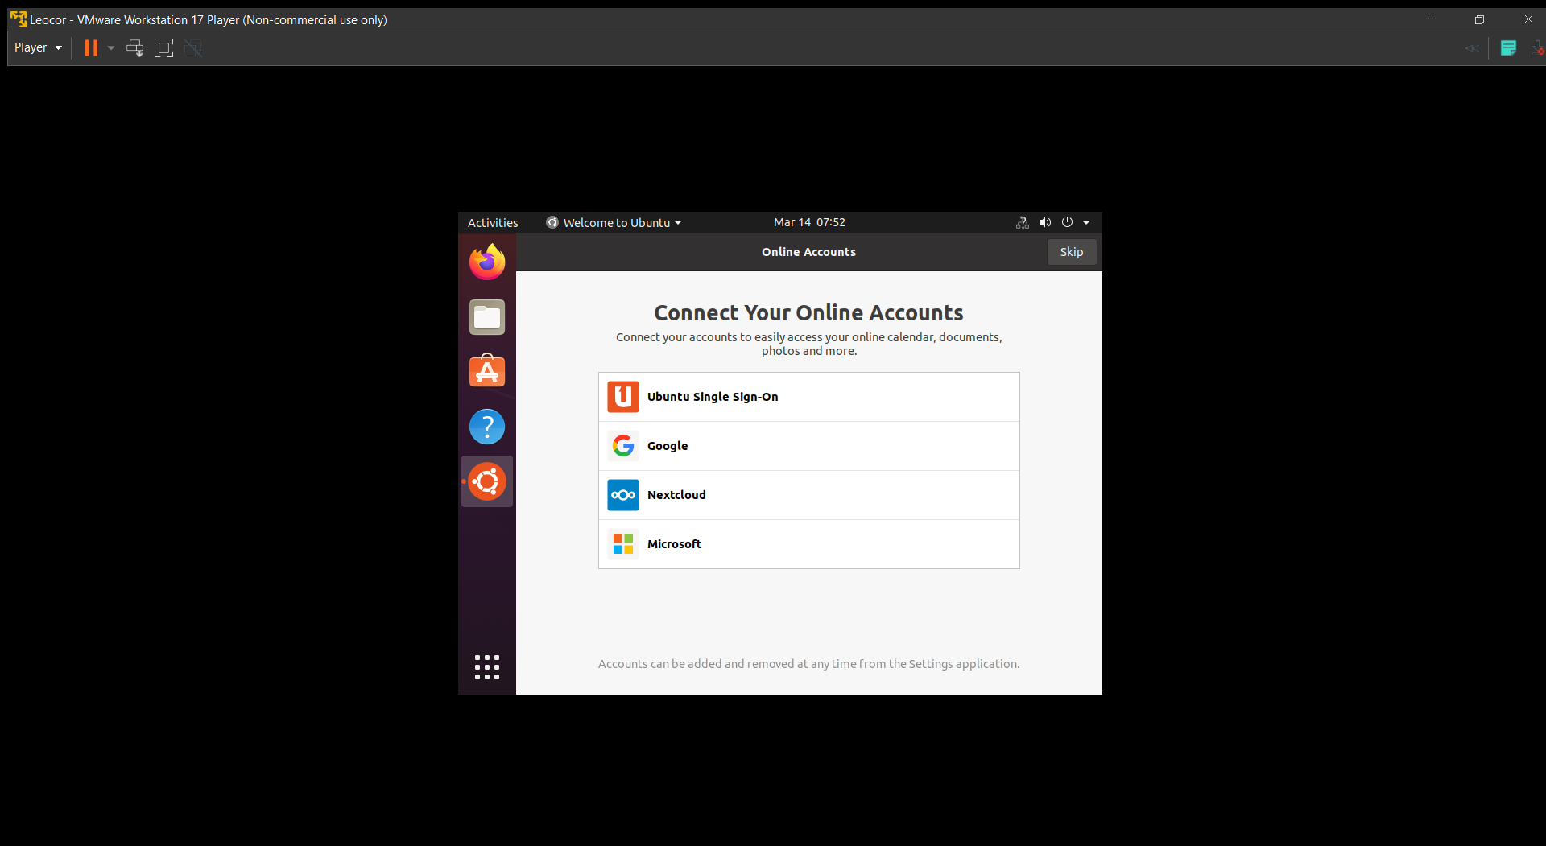

**Step 8:**

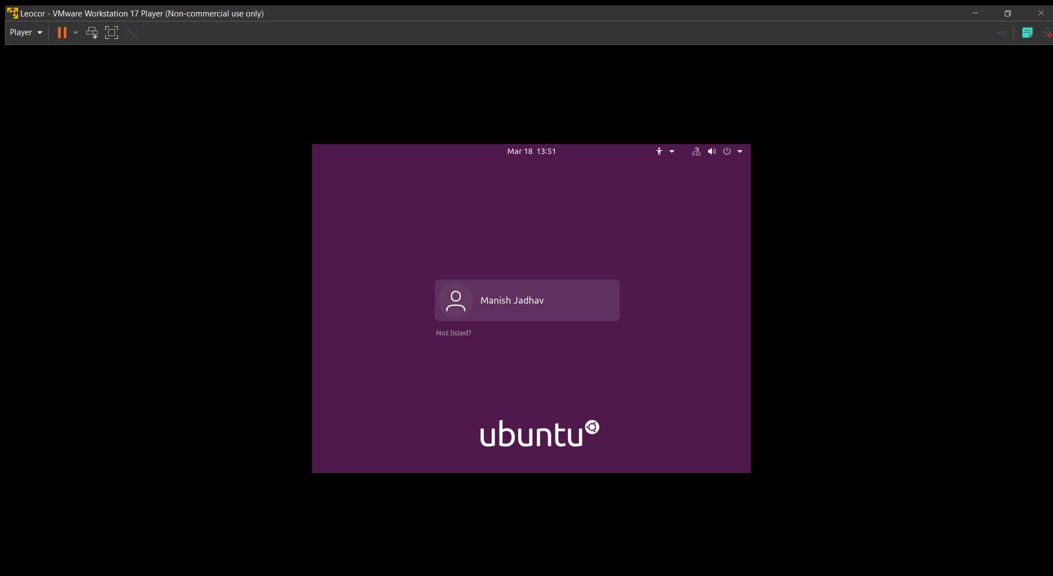

**Step 9:**

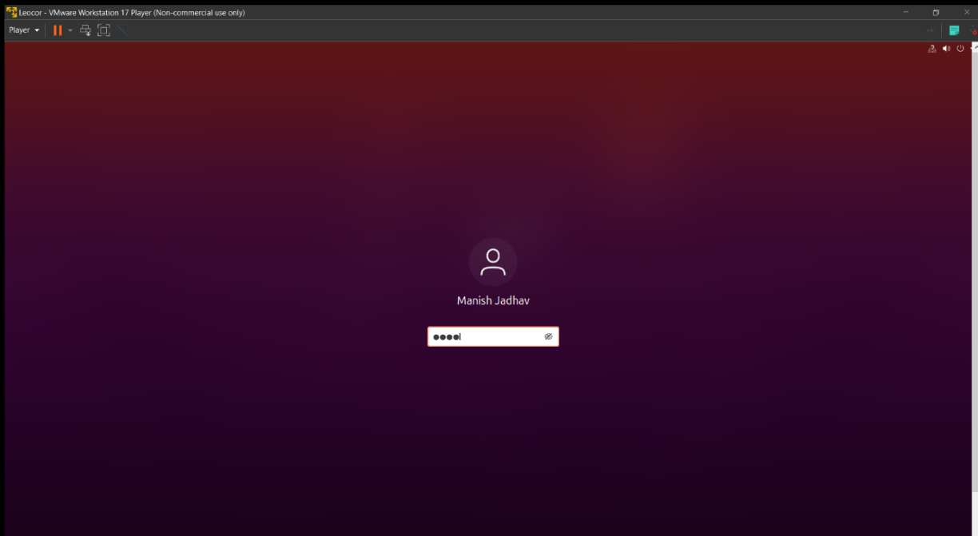

**Step 10:**

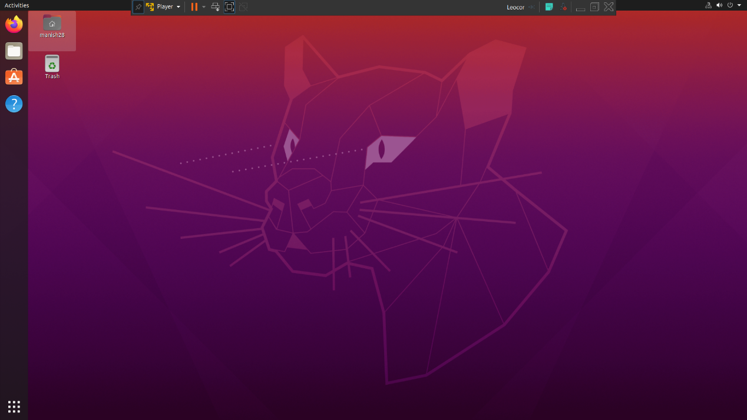

|  |  |  |  |
| --- | --- | --- | --- |
| **Writeup & Oral**  **(4)** | **Practical Performance**  **(4)** | **Attendance**  **(2)** | **Total**  **(10)** |
|  |  |  |  |